

Student Name: Yehia Tarek

Submitted To: Harshit Tyagi

Mentored By: Manish Podival

Report:
Map out a technical solution for the food delivery site ExpressFood

Agenda

Work Flow

Used Tools

UML

SQL Code

Implemented Database

How I designed The Database

- Analyze requirements from clients.
- Decide how many tables I am going to Create.
- Make an ERD UML to make relations between tables.
- Transfer ERD to Database Schema.
- Make SQL code And fill table with dummy data.

Used Tools
- For step one I used paper and pen to brain storm my design.
- Use erdplus Website to make make initial erd diagram.
- Transfer ERD diagram To EERD diagram Using Sql.
- Use phpMyAdmin to create database.
- Fill Database with fake data using Mockaro website.

UML

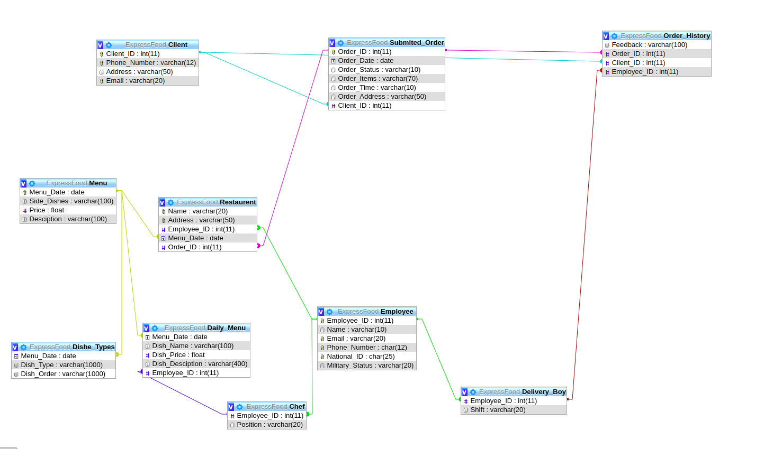

SQL code

1- ExpressFood.sql database
2- Dummy.sql include all dummy data.

Implemented Database
Database file included import it using phpmyadmin.

